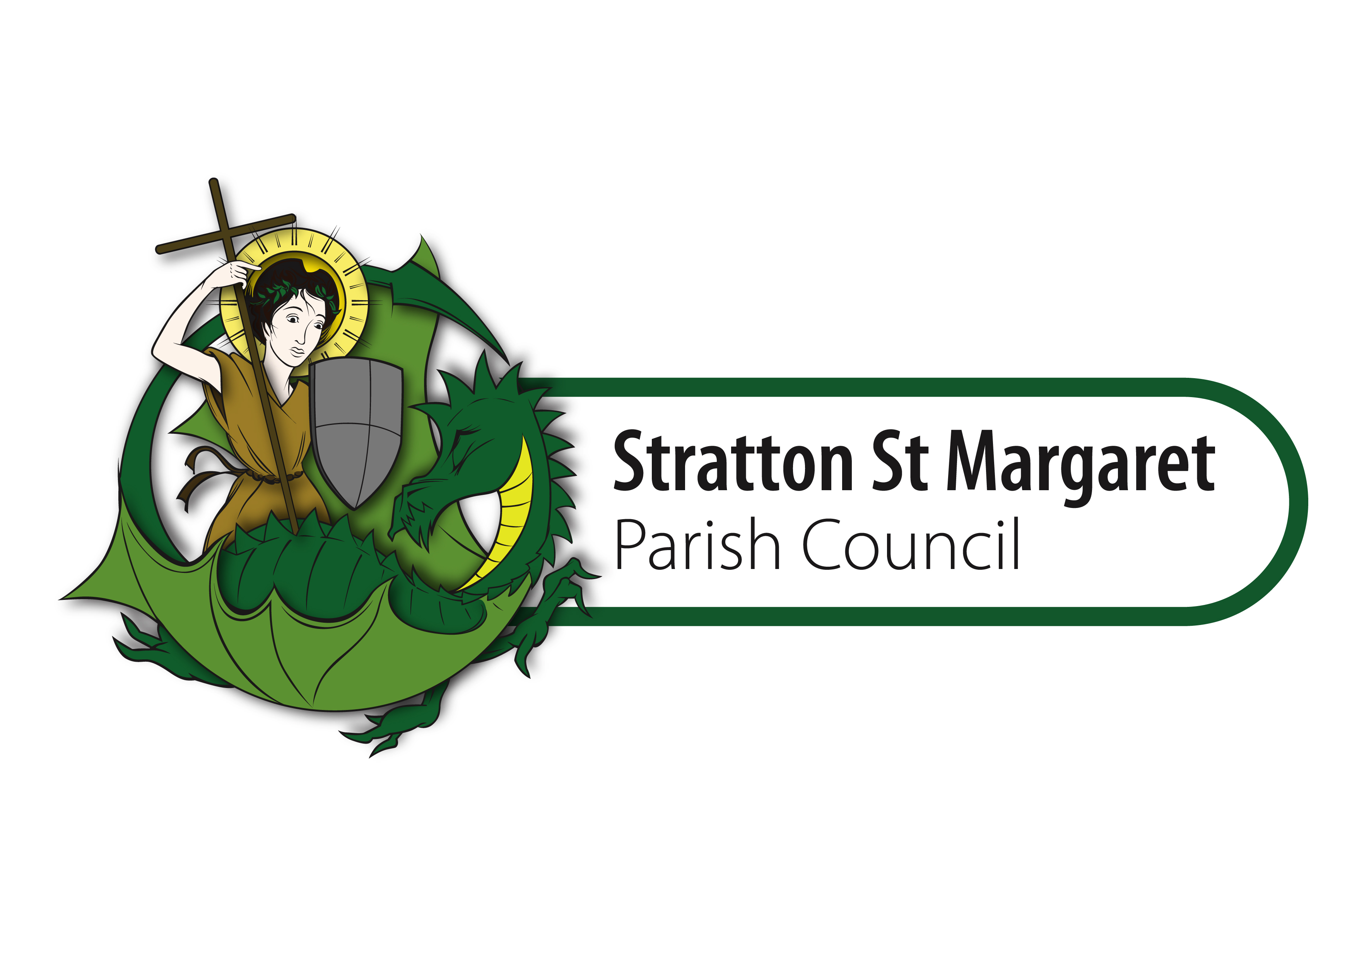
GRANT AID APPLICATION FORM

CONTACT DETAILS
Name of Group/Organisation

Address

Post Code: Email: Fax: Tel No:

Contact Person
Title: First Name:

Surname: Position held in Group:

AIMS AND PURPOSE OF YOUR COMMUNITY GROUP
Charity Registration Number
If you are not a registered charity you must enclose a copy of your constitution

What does your community group/organisation do and how are you financed?

How many people are in your group/organisation

ABOUT YOUR PROJECT
Project Title

Briefly describe your project to enable the Parish Council to understand how its grant will be used:

How many people will benefit from this project? Details of the number of members of your group that are from Stratton and the numbers of people from Stratton St Margaret Parish that will directly benefit from your project would be most helpful.

Estimated cost of project £ Desired grant from Parish Council £

Have any additional grant applications been requested from elsewhere:

FINANCIAL DETAILS
You must include an up to date statement of your group’s financial position (a copy of the latest accounts or a treasurer’s report). If you are holding substantial reserves, you must provide an explanation as to why this project cannot be supported from your own funds. The organisation must have its own bank account with at least two signatories.

DECLARATION
We are authorised to submit this application on behalf of the Group and certify that the information enclosed is correct. We understand that there is no appeal procedure should this application be rejected. If Stratton St Margaret Parish Council gives a grant, we agree to use it only for the purpose given and according to any conditions specified. We understand that within twelve months after payment of a grant, we are expected to provide Stratton St Margaret Parish Council with a report on the progress of this project and how the money has been spent. We are aware that if we do not spend the money as intended Stratton St Margaret Parish Council will ask for the money to be returned.

Signature 1 Date:
(Person submitting form)
Signature 2 Date:
(Chairperson or senior representative of the Management Committee)

CHECKLIST
It is essential that you fill in every question and send the appropriate supporting documentation. Complete the following checklist to show what you have done. If you do not include all the information requested, your application will be incomplete and will take longer to assess or be ineligible. Please do not send any documentation other than that requested.
❐ Answered every question
❐ Enclosed a copy of our constitution (if you are not a registered charity)
❐ Enclosed a copy of our latest accounts and/or treasurer’s statement
❐ Signed the Declaration (two signatures if possible)

I have:

(Please tick)

ALL APPLICATIONS FOR FINANCIAL ASSISTANCE ARE CONSIDERED ON THEIR INDIVIDUAL MERITS. APPLICATIONS MUST BE SUBMITTED WELL IN ADVANCE OF YOUR PROJECT TAKING PLACE IN ORDER TO BE CONSIDERED AT THE APPROPRIATE MEETING

Completed Application Forms should be returned to:
Stratton St Margaret Parish Council, Meadowcroft Community Centre, Addison Crescent, Swindon, SN2 7JX
Tel : 01793 823761 email: finance@strattonstmargaret.gov.uk

